To finish the task, we need to use 4 terminals to finish the **GridProblem** in real environment. please keep the terminal (for jupyter notebook) alive, then type **[ctrl + shift + T]** to turn on a new terminal.

(Terminal 2) → *to turn on the control part on mmbot*

**laptop $ ssh ubuntu@mm_pi_14** # or mm_pi_16

**mmbot $ source sis_cometition_base_TA/catkin_ws/devel/setup.sh**

**mmbot $ roslaunch demo hcc_demo.launch**

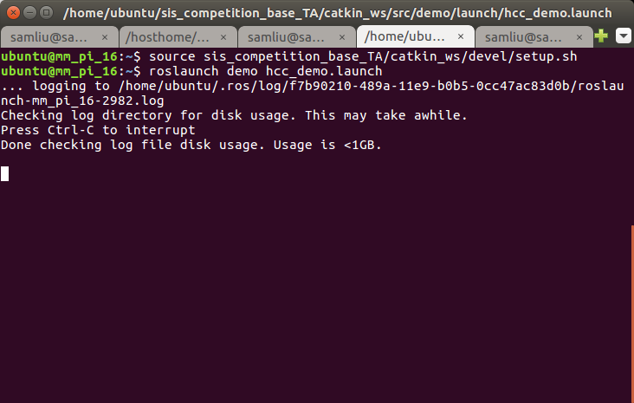

(Terminal 3) → *to turn on the car command transmission part on laptop*

**laptop $ docker exec -it hcc_lab3 bash**

**container $ source set_ros_master.sh [ROS_MASTER_IP]**

**container $ source catkin_ws/devel/setup.sh**

**container $ roslaunch demo hcc_demo.launch bot:=mmbot14** # or mmbot16

(Terminal 4) → *to config parameters of car command transmission part on laptop*

**laptop $ docker exec -it hcc_lab3 bash**

**container $ source set_ros_master.sh [ROS_MASTER_IP]**

**container $ cd catkin_ws**

**container $ source devel/setup.sh**

**container $ rosrun rqt_gui rqt_gui -s reconfig**

The configuration window will pop-up

# 

To load PID configuration file, please click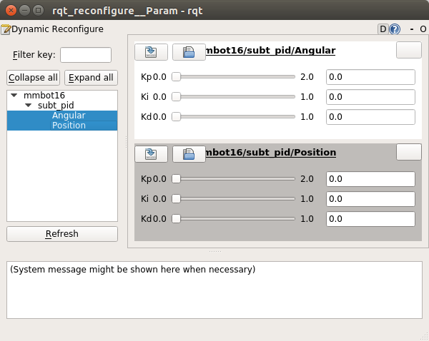, and find “**catkin_ws/src/demo/config/”,** you will see there are two config file named *.yaml shown below, select a one which correspond to the setting. Both Angular and Position need to be reconfig.

